The Album “BAIANA” – Baiana Music
Worldwide Digital Release: 22nd September 2023
CD Release: 29th September / Vinyl Release 27th October 2023 (tbc)

What they say

“Joyful yet wistfully nostalgic…sexy yet pensive…5/5” UK VIBE
“So Good" Gilles Peterson, 6 Music
"The band we're all obsessed about" Deb Grant 6 Music
"Addictive" - John Osborne, Jazz Fm
"Hottest record on the planet" Simon Phillips Jazz FM

Snowboy-produced debut album from
Liverpool-born Brazilian jazz artist

Baiana (pronounced By-Anna) is the alias of powerhouse Liverpool-born Brazilian jazz artist, Laura Doyle. Following on from performances at Love Supreme, Ealing Jazz festival, opening for Brazilian mega star Gilberto Gil on his UK tour, as well as an unprecedented 12 weeks on the A-list of the Jazz FM playlist, with her breakthrough single “Saudade Samba” Baiana's highly anticipated self-titled debut album is finally here.

Produced by the legendary UK Latin percussionist, Snowboy, 'Baiana' features 11 finely crafted songs covering a huge range of Brazilian styles from fiery Sambas to Bossa Nova, Jazz Fusion to Baião and everything in-between. Singing in both Portuguese and English, Laura evokes a vocal style reminiscent of the great romantic torch singers of the 40's and 50's such as Julie London and Peggy Lee and yet one can clearly also feel the passionate expression of Portuguese Fado and the Brazilian greats such as Elza Soares, Gal Costa and Elis Regina as she sings of love-lost and broken hearts.
An unexpected candidate for Brazilian jazz with her Scouse accent and fiery red hair denoting her Irish roots, Laura became enraptured by Brazilian music after living in Rio de Janeiro where she was seconded as “first lady” with the Italian diplomatic service.
“Arriving in Brazil was love at first sight and it immediately felt like home. The Carioca spirit especially is very much like Liverpool; their humour, that playful, streetwise charm and the music… music everywhere! It was like Rio had its very own soundtrack. I wanted to get as deep into their culture as I could, so taught myself Portuguese which led me to discover the lyrical beauty of the music too and I was hooked.”
Laura’s musical career however, didn’t start till much later in life and her many diverse experiences before this explain her rich storytelling and kaleidoscopic style as she went on to study clowning with the great Phillip Gaulier in Paris, become a stand-up comedian, a translator and an international football agent .Yet her passion for Brazilian music only grew stronger until she could no longer ignore the calling and, as she herself attests “put her shirt” on launching Baiana
“I’m not a trained musician so I had to rely on my creative instinct. I experience music as pictures in my mind, almost like a film and I try to interpret and express what the characters in that story are doing, thinking and feeling. Whether I was writing lyrics or wanting to capture a particular sound I would imagine it visually first and then draw on that as a way of expressing it musically”
Brought together by a shared passion for Brazilian music, the internationally acclaimed artist Snowboy agreed to produce Baiana after hearing the demos for Paradise and Saudade Samba and was drawn to the authentic and heartfelt nature of her work. Thus started their unexpected yet alchemical collaboration spending weeks together in the studio as Snowboy beautifully, skilfully and sensitively brought Laura’s vision to life. Drawing on his vast knowledge of Latin jazz, his innate musicality and organic approach to making music which he believes is best born out of the energy of the moment and the musicians in the room. It is clear on this album he has captured not only her sound but her character.
Recorded at Liverpool's famous Motor Museum and the country's leading roots music studio, Big Noise, in Essex the album features the finest jazz and Brazilian musicians that Liverpool has to offer and many other special guests including the legendary Haggis Horns on all tracks, who have also featured with Mark Ronson, Amy Winehouse and Jamiroquai amongst many others.
The album also features sublime solos from some of the UK’s jazz greats such as Malcolm Strachan and Trevor Mires and the dreamy Claus Ogerman inspired string arrangements of Steve Parry and Liverpool based string section. Together this results in a deep, dramatic and panoramic Brazilian Jazz soundscape, beautifully Mastered at Abbey Road Studios (you can't keep Scouser's out of Abbey Road!).
As Laura herself describes it, “Baiana is me; it’s my life, my experiences and who I was always meant to be” and here it is…at last.
Notes to editor:

Baiana is available on all streaming platforms
Website: www.baiana.co.uk Socials: @baianaband Youtube: Baiana Band

About Laura Doyle
Laura Doyle’s life reads like something of a film script. Born and bred in Liverpool, she has been a flight attendant, “First Lady” with the Italian diplomatic service in Brazil and Norway, head of the Cuban desk at an international law firm, studied clowning under the great Philippe Gaulier in Paris, been a stand-up comedian, a cabaret performer, a translator and an international Premier League player manager.
As well as a professional recording artist, she is also Head of Women’s Football at one of the biggest sports agencies in the world, CAA Stellar. She manages the careers of some of the brightest young female sports stars in the women’s game, speaks (and sings) Portuguese, French, Spanish and Italian.
Alongside her football career, she writes and performs under the alias of Baiana who’s music has received critical acclaim, featured on Channel 4, BBC national radio and spent an unprecedented 12 weeks on the A-List of Jazz FM.
She was inspired to form Baiana (pronounced “By Anna” which means ‘woman of Bahia’, a region of Brazil), after living in Rio de Janeiro, where she became enraptured by Brazilian culture and fell under the spell of musicians such as Gal Costa, Gilberto Gil, Elis Regina, Caetano Veloso and João Gilberto.
Although life took on many t twists and turns, her love of Brazilian music together with a burning desire to forge a creative path, finally led her to follow her heart.
For more information contact Chris Hewlett on 0845 601 2833 or chris@chrishewlett.com

A selection of pictures follows below. Hi-res versions on request
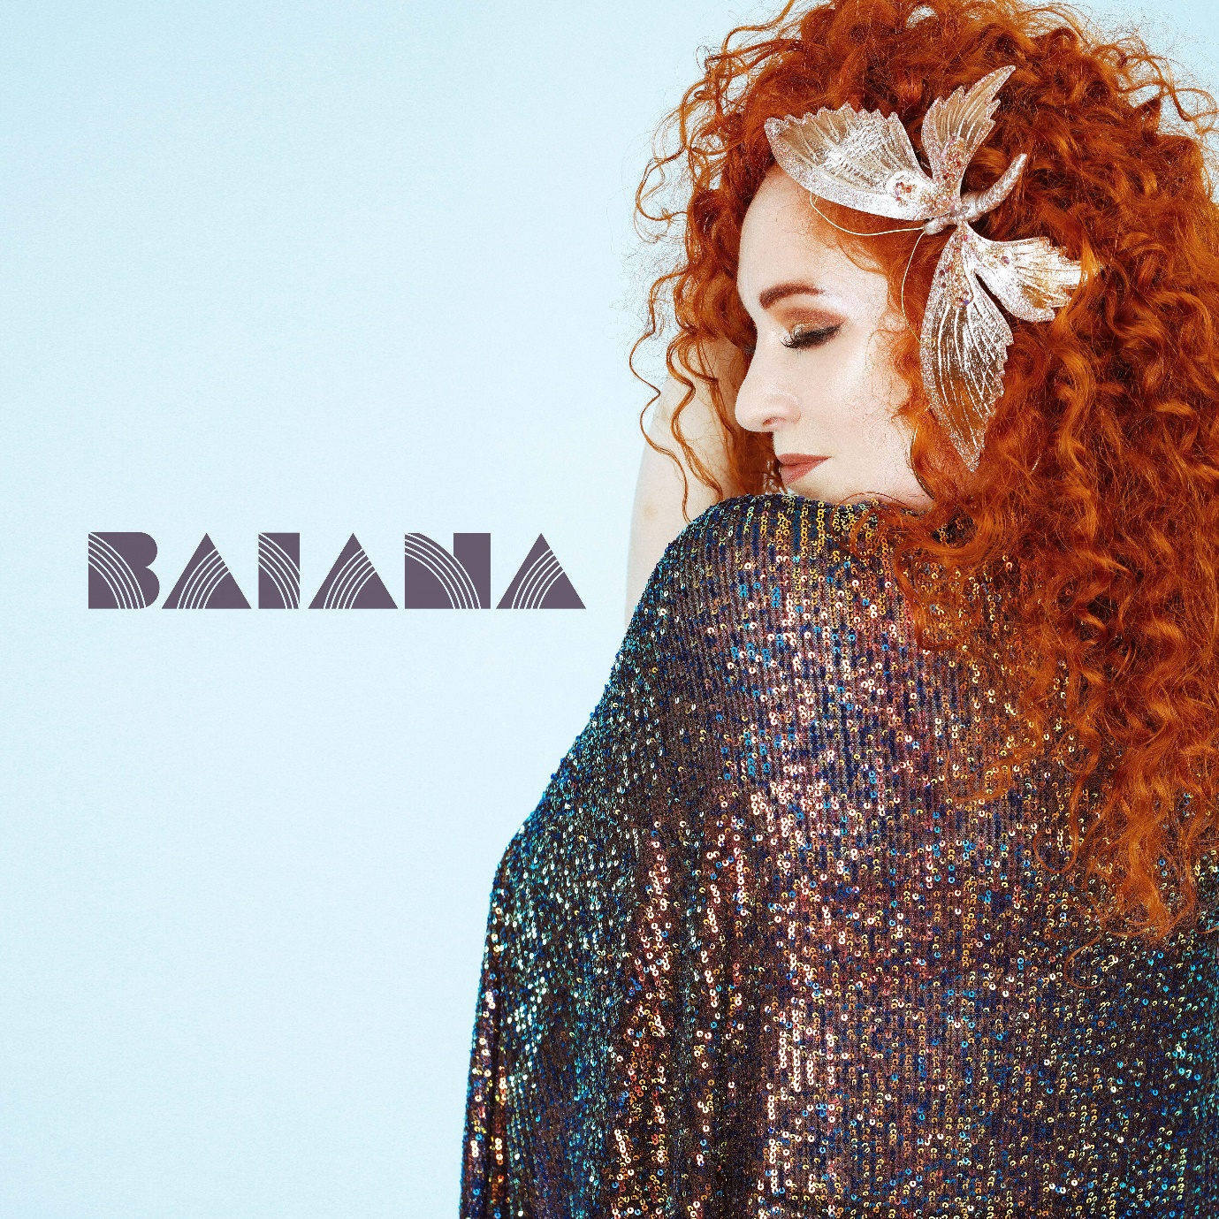
Figure 1Album Cover

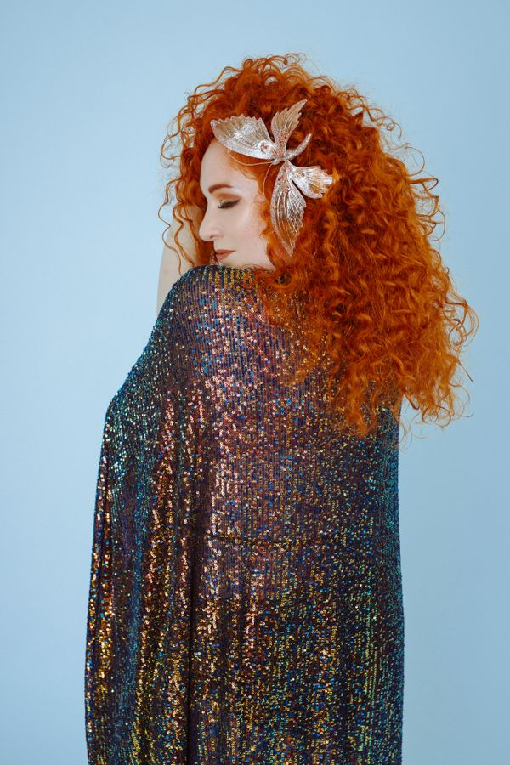
Figure 2Laura Doyle
Figure 3 laura Doyle
